Twisted Tactics Battle System

Version <1.1>
Submit Date<18MAY 2011>
Revision History
Date | Version | Description | Author
<04DEC2010> | <1.0> | Class Portfolio | Cris Kamurai
<18MAY2010> | <1.1.> | Master Classes Added | Cris Kamurai

Table of Contents
Page

1. Introduction 4

1.1 Purpose 4

1.2 Scope 4

1.4 References 5

2. Class Designs 6

2.1 Class Listing 6

2.1 Class Tables 6

2.1 Class Diagrams 6

3. Interaction Design 6

3.1 State Behavior Design 6

3.2 Collaboration Design 6

3.3 Sequence Design 6

4. Supporting Information 22
Appendix 22
Index 23

Class Portfolio

1. Introduction
<State what this document is and related documents.>

This document is designed to express which classes will be required for the project to work effectively.

Purpose
<State the purpose of this document and what information it is supposed to provide.>

The purpose of this document is to determine which features will be necessary for the program, based on the needs of the project.

Scope
<This section should list the goals, and priorities of what is to be accomplished in this document.>

The scope of this document is to use basic language and UML diagrams to explain and determine the project’s necessary classes, most likely per screen.

References
<This section should list references to information sources outside the creative properties of the authors>

All GDR documentation for Twisted Tactics Battle System.

2. Class Designs
<This section should contain a full description of classes required for the game.>

The following section contains information on the designs for the project’s potential classes.

2.1 Class Listings
<This section should contain a full listing, possibly divided into sub categories, of classes that are to be used for each screen designed in the game.>

2.1.1 Master Classes These are unique and are persistent throughout the application.
Master_Info:
Holds information for game mechanics.
Master_Mode:
Holds user based decisions.
2.1.2 Title Classes
Title_Controller:
Mediates page functions, i.e. navigation.
Title_Logo:
Displays the logo sprite.

2.1.3 Title Menu Classes
TitleMenu_Controller:
Mediates screen functions, i.e. selection and navigation.

TitleMenu_PlayerMode1:
Marker for 1 Player mode.

TitleMenu_PlayerMode2:
Marker for 2 Player mode.

TitleMenu_LoadParty:
Marker for using a pre-designated party.

TitleMenu_LoadStock:
Marker for using stock characters.

TitleMenu_Arrow:
Used to point at Menu choices.

TitleMenu_Menu:
Used to orient Menu choices.

TitleMenu_Help:
Marker for Help and Information.

TitleMenu_CharacterSelect:
Marker for Character Selection.

2.1.4 Character Selection Classes
CharacterSelection_Controller:
Mediates screen functions, i.e. selection and navigation.

CharacterSelection_Character:
Represents a character desired to be placed on the tactical board.

CharacterSelection_Cursor:
Used to point at objects on the tactical board.

CharacterSelection_Switch:
Used to mediate player control.

CharacterSelection_Menu:
Used to orient Menu choices.

CharacterSelection_MenuItem:
Marker used to represent a Menu choice.

CharacterSelection_Arrow:
Used to point at Menu choices.

CharacterSelection_Board:
Used to “hold” characters in the battle.

CharacterSelection_Square:
Markers for potential character locations on the board.

CharacterSelection_Display:
Shows “short” information on the “highlighted” character.

CharacterSelection_PlayerDisplay:
Show what player’s turn it is currently.

2.1.5 Information Classes
Information_Controller:
Mediates screen functions, i.e. selection and navigation.

Information_Instructions:
Marker for a sprite with instructions on how to use the program.

2.1.6 Playable Game Classes
Play_Controller:
Mediates screen functions, i.e. selection and navigation.

Play_Menu:
Used to orient Menu choices.

Play_Arrow:
Used to point at Menu choices.

Play_MenuItem:
Marker used to represent a Menu choice.

Play _Character:
Represents a character desired to be placed on the tactical board.

Play _Cursor:
Used to point at objects on the tactical board.

Play _Switch:
Used to mediate player control.

Play_Board:
Used to “hold” characters in the battle.

Play_Square:
Markers for potential character locations on the board.

Play_Display:
Shows “short” information on the “highlighted” character.

Play_SubMenu:
Used to orient Menu choices.

Play_SubMenuItem:
Marker used to represent a Menu choice.

2.1.7 Party Menu Classes
PartyMenu_Controller:
Mediates screen functions, i.e. selection and navigation.

PartyMenu_Board:
Used to “hold” characters in the battle.

PartyMenu_Square:
Markers for potential character locations on the board.

PartyMenu_Cursor:
Used to point at objects on the tactical board.

PartyMenu_Character:
Represents a character on the tactical board.

PartyMenu_Display:
Shows “short” information on the “highlighted” character.

2.1.8 Character Menu Classes
CharacterMenu_Controller:
Mediates screen functions, i.e. selection and navigation.

CharacterMenu_Character:
Represents a character on the tactical board.

CharacterMenu_Display:
Shows detailed information on the chosen character

CharacterMenu_Menu:
Used to orient Menu choices.

CharacterMenu _Arrow:
Used to point at Menu choices.

CharacterMenu _MenuItem:
Marker used to represent a Menu choice.

CharacterMenu_SubMenu:
Used to orient Menu choices.

CharacterMenu _SubMenuItem:
Marker used to represent a Menu choice.

2.2 Class Tables
<This section should contain a table for each class, possibly divided into sub categories, giving the attributes and potential methods for that class.>

Class Diagrams
<This section should contain relational and dependency diagrams, possibly divided into sub categories, for all the classes that are to be used for each screen designed in the game.>

The following section includes Cardinality and Dependency Diagrams

2.3.1 Cardinality Diagrams

2.3.1.1 Master Class Cardinality
It is assumed that there is always one, and only one, of any master class existing at any point in the application.

2.3.1.2 Title Screen Cardinality
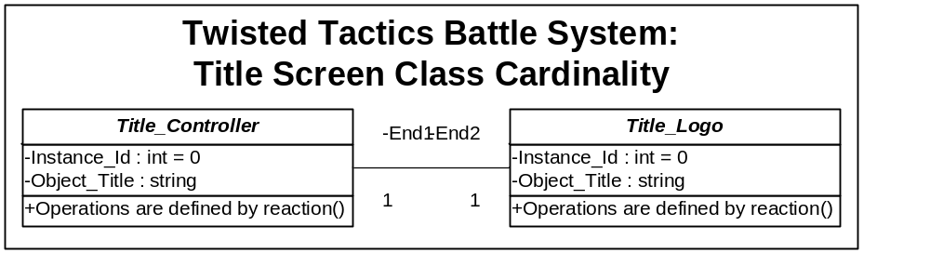

2.3.1.3 Title Menu Screen Cardinality
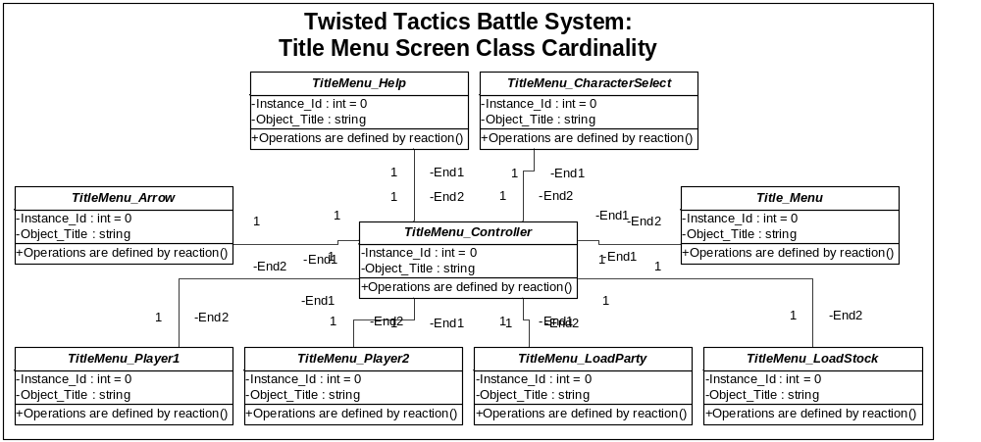

2.3.1.4 Information Screen Cardinality
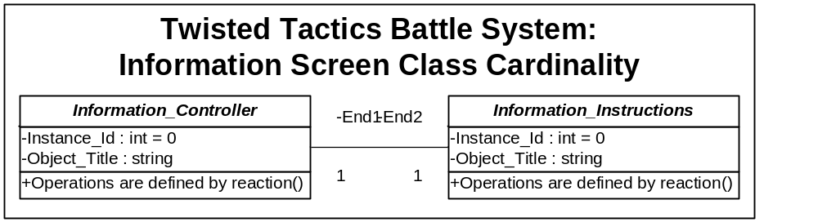

2.3.1.5 Character Selection Screen Cardinality
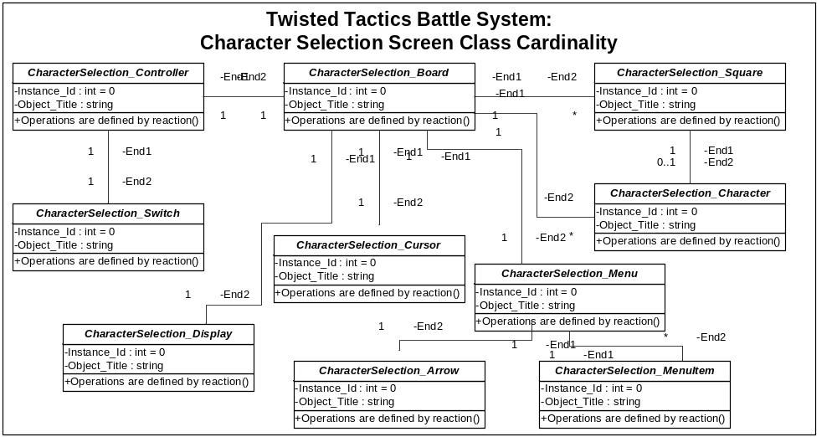
2.3.1.6 Playable Screen Cardinality
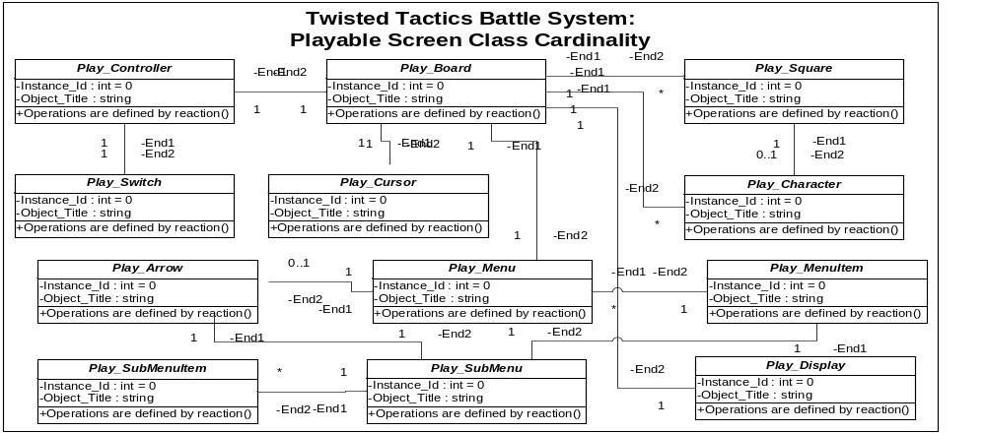

2.3.1.7 Party Menu Screen Cardinality
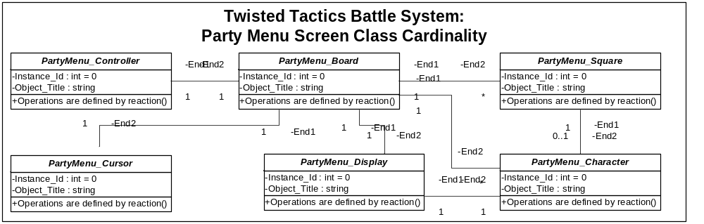
2.3.1.8 Character Menu Screen Cardinality
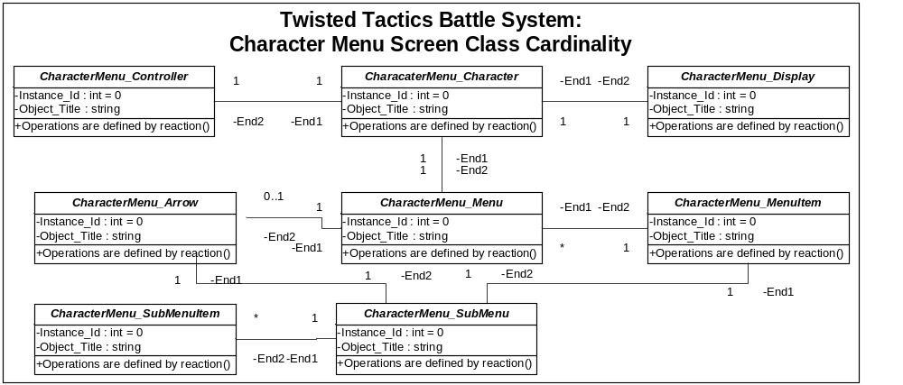
2.3.2 Dependency Diagrams

2.3.2.1 Utiltiy Object Dependency
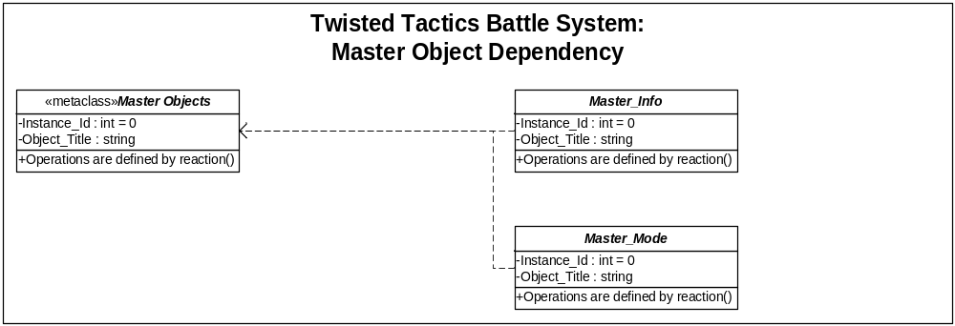

2.3.2.2 Utiltiy Object Dependency
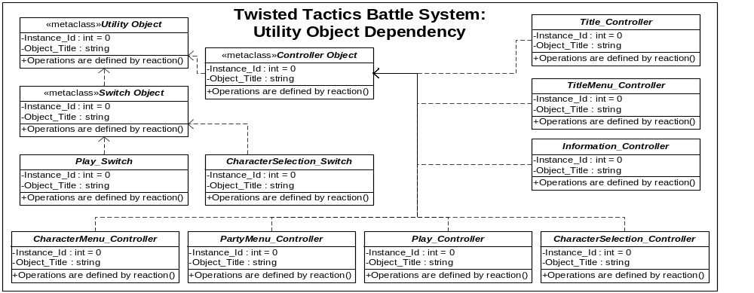
2.3.2.3 Display Object Dependency
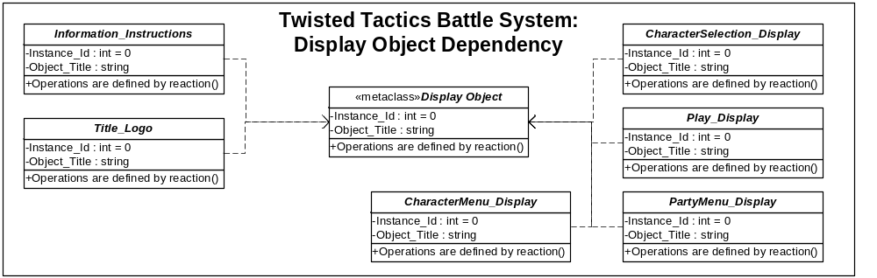

2.3.2.4 Interface Object Dependency
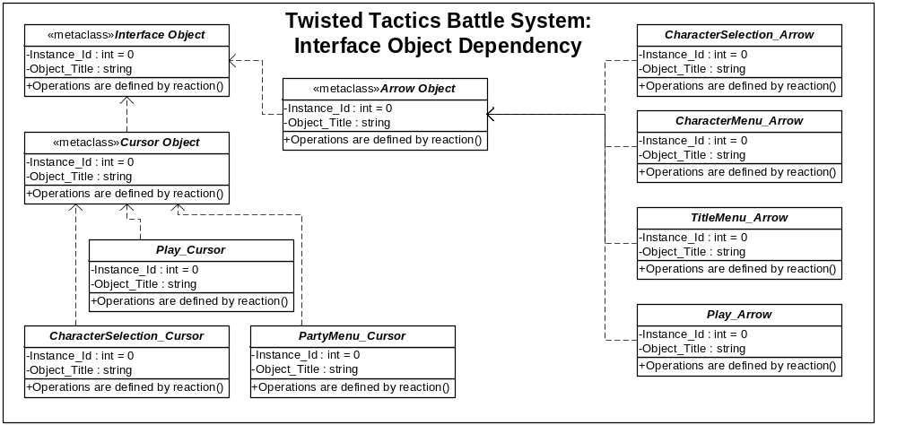
2.3.2.5 Play Object Dependency
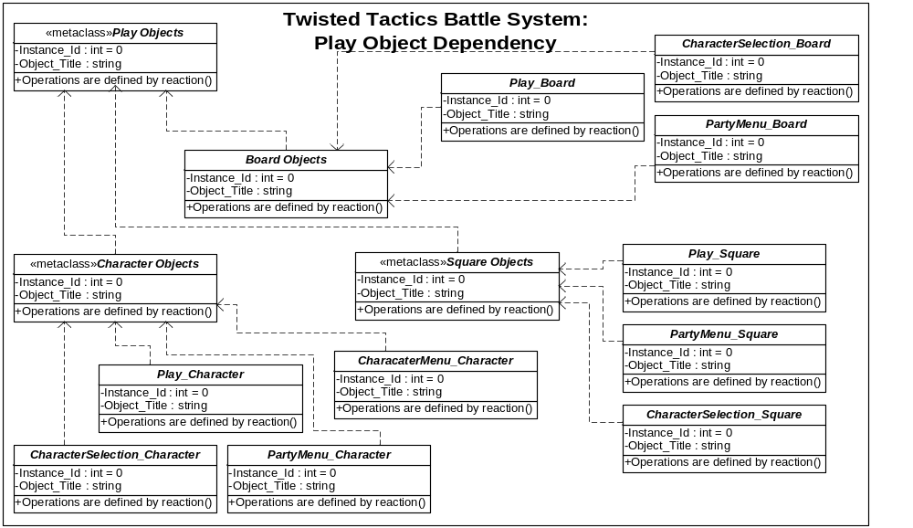

2.3.2.6 Menu Object Dependency
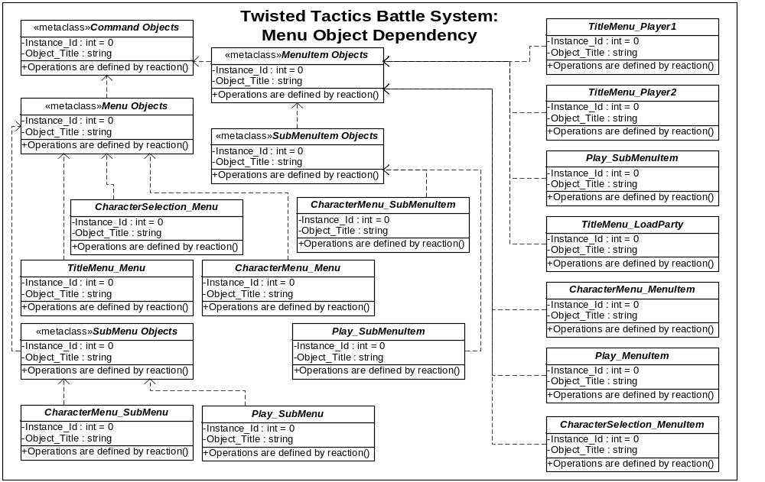

3. Interaction Design
<This section should be dependent and map directly to the Use Cases.>
<This section should include interaction diagrams for all the Use Cases.>

The following section includes State Behavior, Collaboration and Sequence Diagrams

3.1 State Behavior Design
<This section should be dependent and map directly to the class design.>
<This section should include state behavior diagrams for all the classes. These represent how objects change state during use.>

3.1.1 Master Class Object State Behavior

It is assumed that these objects remain in an available, accessible for the duration of the application.

3.1.2 Display Object State Behavior
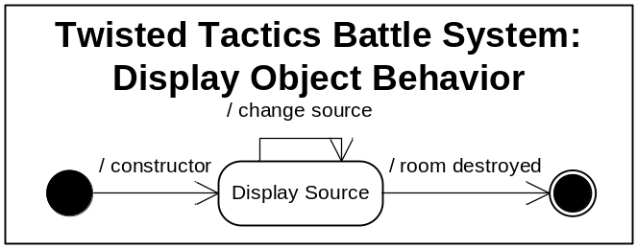

3.1.3 Switch Object State Behavior
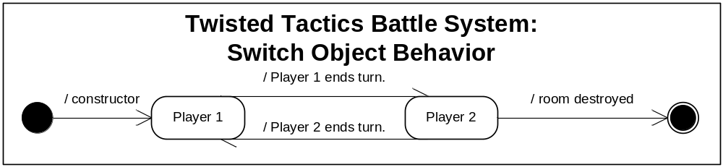

3.1.4 Cursor Object State Behavior
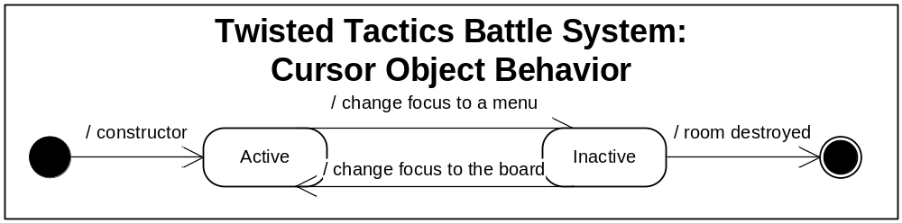

3.1.5 Arrow Object State Behavior
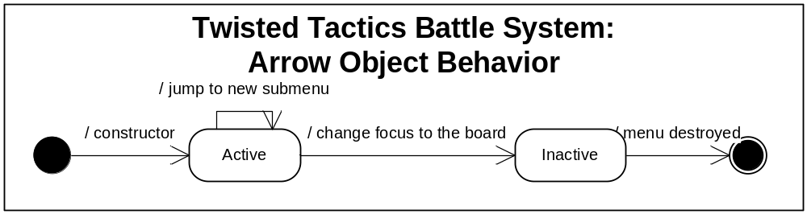

3.2 Collaboration Design
<This section should be dependent and map directly to the Use Cases.>
<This section should include collaboration diagrams for all the Use Cases. These represent how which objects interact with other objects.>

3.2.1 Title Screen Collaborations

3.2.2 Title Menu Screen Collaborations

3.2.3 Information Screen Collaborations

3.2.4 Character Selection Screen Collaborations

3.2.5 Playable Screen Collaborations

3.2.6 Party Menu Screen Collaborations

3.2.7 Character Menu Screen Collaborations

3.3 Sequence Design
<This section should be dependent and map directly to the Use Cases.>
<This section should include sequence diagrams for all the Use Cases. These represent the order in which Use Cases are executed and how.>

3.3.1 Title Screen Collaborations

3.3.2 Title Menu Screen Collaborations

3.3.3 Information Screen Collaborations

3.3.4 Character Selection Screen Collaborations

3.3.5 Playable Screen Collaborations

3.3.6 Party Menu Screen Collaborations

3.3.7 Character Menu Screen Collaborations

4. Supporting Information
<Any further information or locations at which further information may be obtained may be listed here.>

Appendix:
<Additional documentation that does not warrant an entirely separate document may be listed here.>

Index
Page
Table of Contents 3

1. Introduction 4

1.1 Purpose 4

1.2 Scope 4

1.4 References 5

2. Background Listings 6

3. Sprite Listings 6

4. Room Designs 18

4.1 Key 18

4.2 Layouts 19

5. Supporting Information 22
Appendix 22

